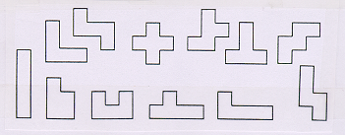

The twelve possible figures formed by five squares

From Reza Sarhangi’s “The Art and Mathematics of Tessellation” (Mathematics Department, Towson University, Towson, MD 21252, <rsarhangi@towson.edu>)

